



FUNDAMENTALS of
WEB DESIGN
(405)

STATE 2021

Production:
Multiple Choice (20 @ 5 points each) __________ (100 points)
HTML Application __________ (125 points)
CSS Application __________ (85 points)

TOTAL POINTS __________ (310 points)

Test Time: 90 minutes

Multiple Choice:

- C
- D
- A
- B
- B
- A
- D
- A
- C
- C
- C
- B
- A
- D
- A
- D
- A
- B
- D
- A

Application

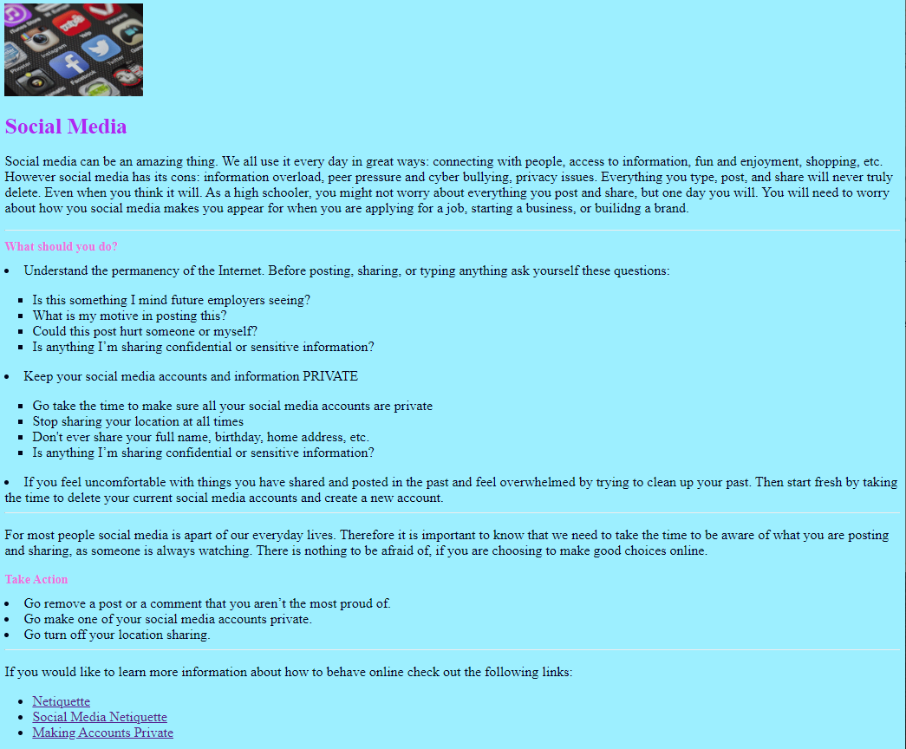

HTML ANSWER KEY
<!doctype html>
<html lang=”en”>
<head>
<meta charset="UTF-8">
<title>Social Media - Contestant ##</title>
<link rel="stylesheet" href="stylesheet.css"/>
</head>
<body>
<img src="socialmedia.PNG" class=="image" alt="Social Media Picture">
<p><span class="heading ">Social Media</span></p>
<p>Social media can be an amazing thing. We all use it every day in great ways: connecting with people, access to information, fun and enjoyment, shopping, etc. However social media has its cons: information overload, peer pressure and cyber bullying, privacy issues. Everything you type, post, and share will never truly delete. Even when you think it will. As a student, you might not worry about everything you post and share, but one day you will. You will need to worry about how you social media makes you appear for when you are applying for a job, starting a business, or building a brand. </p>
<hr>
<h1 class="title">What should you do?</h1>
<li>Understand the permanency of the Internet. Before posting, sharing, or typing anything ask yourself these questions:</li>
<ul>
<ul class="square">
<li>Is this something I mind future employers seeing?</li>
<li>What is my motive in posting this?</li>
<li>Could this post hurt someone or myself?</li>
<li>Is anything I’m sharing confidential or sensitive information?</li>
</ul>
</ul>
<li>Keep your social media accounts and information PRIVATE</li>
<ul>
<ul class="square">
<li>Go take the time to make sure all your social media accounts are private</li>
<li>Stop sharing your location at all times</li>
<li>Don't ever share your full name, birthday, home address, etc.</li>
<li>Is anything I’m sharing confidential or sensitive information?</li>
</ul>
</ul>
<li>If you feel uncomfortable with things you have shared and posted in the past and feel overwhelmed by trying to clean up your past. Then start fresh by taking the time to delete your current social media accounts and create a new account.</li>
<hr>
<p> For most people social media is apart of our everyday lives. Therefore it is important to know that we need to take the time to be aware of what you are posting and sharing, as someone is always watching. There is nothing to be afraid of, if you are choosing to make good choices online. </p>
<h1 class="title">Take Action</h1>
<li>Go remove a post or a comment that you aren’t the most proud of. </li>
<li>Go make one of your social media accounts private.</li>
<li>Go turn off your location sharing.</li>
<hr>
<p>If you would like to learn more information about how to behave online check out the following links:</p>
<ul>
<li><a href="https://www.utep.edu/extendeduniversity/utepconnect/blog/october-2017/10-rules-of-netiquette-for-students.html">Netiquette</a></li>
<li><a href="https://networketiquette.net/en/social-media-netiquette/">Social Media Netiquette</a></li>
<li><a href="https://nordvpn.com/blog/7-tips-to-make-social-media-profiles-private/">Making Accounts Private</a></li>
</ul>
</body>
</html>

CSS ANSWER KEY

body {
font-family: "Times New Roman", Times, serif;
font-size: 20px;
color: #00051A;
background-color: #9DEFFF;
}
.heading {
font-size: 32px;
font-weight: bold;
color: #AE28F2;
}
.title {
font-family: "Times New Roman", Times, serif;
font-size: 18px;
color: #ED6DDF;
}
.image {
text-align: left;
width: 50px;
height: 5px;
}
.square {
list-style-type: square;
margin-left: -2em;
}

APPLICATION RUBRIC

HTML | Point Value | Score
Correct DOCTYPE declaration | 5
Set document to <meta charset=”UTF-8”> | 5
<head> tag properly placed and used | 5
Document is set to English | 5
<title> tag includes contestants BPA membership number | 10
<link> tag reference to a CSS stylesheet | 10
<body> tag has no attributes | 5
Place Social Media Picture with correct alternative name “Social Media Picture” | 5
<hr> was used 3 times in the correct spots | 10
Had the correct headings for each title | 20
Have all the text for the paragraph in <p> tags with no mistakes or misspellings - 5 points taken off for misspellings | 15
Correct coding for bulleted list | 15
The last 3 bullets included hyperlinks to the correct websites | 15
HTML TOTAL | 125

CSS | Point Value | Score
Style Sheet is external: (Can be called anything) | 10
body { background-color: #9DEFFF; | 5
body { font-family: ‘Times new Roman’, Times, Serif | 5
Body Font size was set to 20px and color: #00051A; | 10
Heading Class was: font-family: "Times New Roman", Times, serif; | 5
Heading Class font size was 32, bold, and color: #AE28F2 | 15
Title Class was "Times New Roman", Times, serif; | 5
Title Class font size was 18p and color #ED6DDF | 10
Image Class is text aligned left, width 50px and height 5px | 10
Level 2 bullets had a Square Class with a list style of square and left margin of -2em | 10
CSS TOTAL | 85
 | Point value | Score
Application Total | 210
Objective Total | 100
EVENT TOTAL | 310

